IS YOUR FAMILY NEW TO HOCKEY??

Step 1) Go to the Respect in Sport Website
@ Respect in Sport for Hockey Canada Parents - Getting Started (respectgroupinc.com)
create an account and complete the course

Use the visual Aid below to aid you in the process 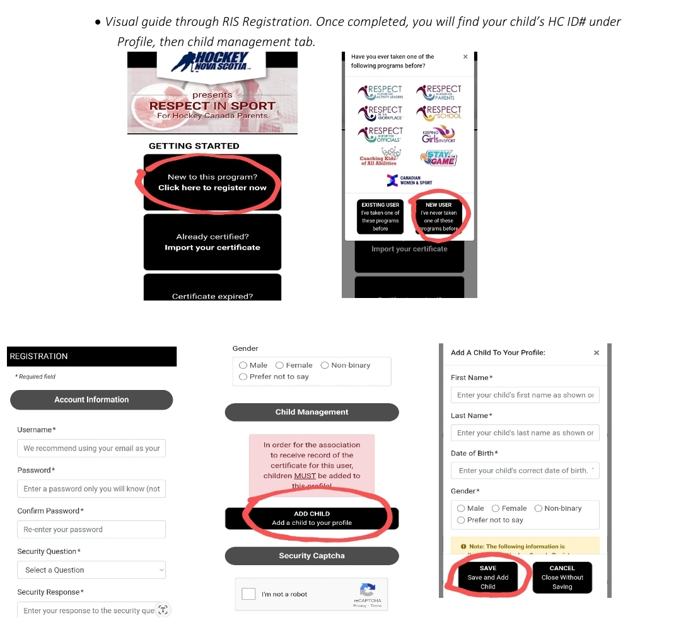
Step 2. Once you have completed the online course and created your childs Hockey Canada Registration number please proceed to the Acadiaminorhockey.ca website

Step 3 Find the Registration tab along the top left, click and choose 2024/25 Season Registration
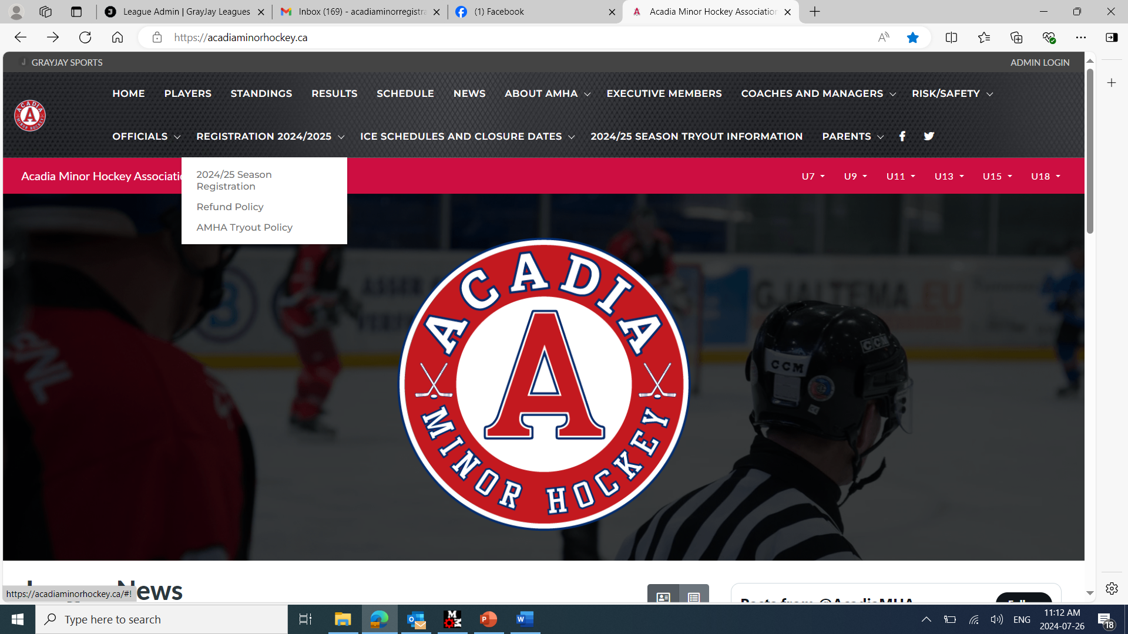

Step 4. From here you will be asked to create a Grayjay pay account by choosing the Signup button at the top right corner of the page.

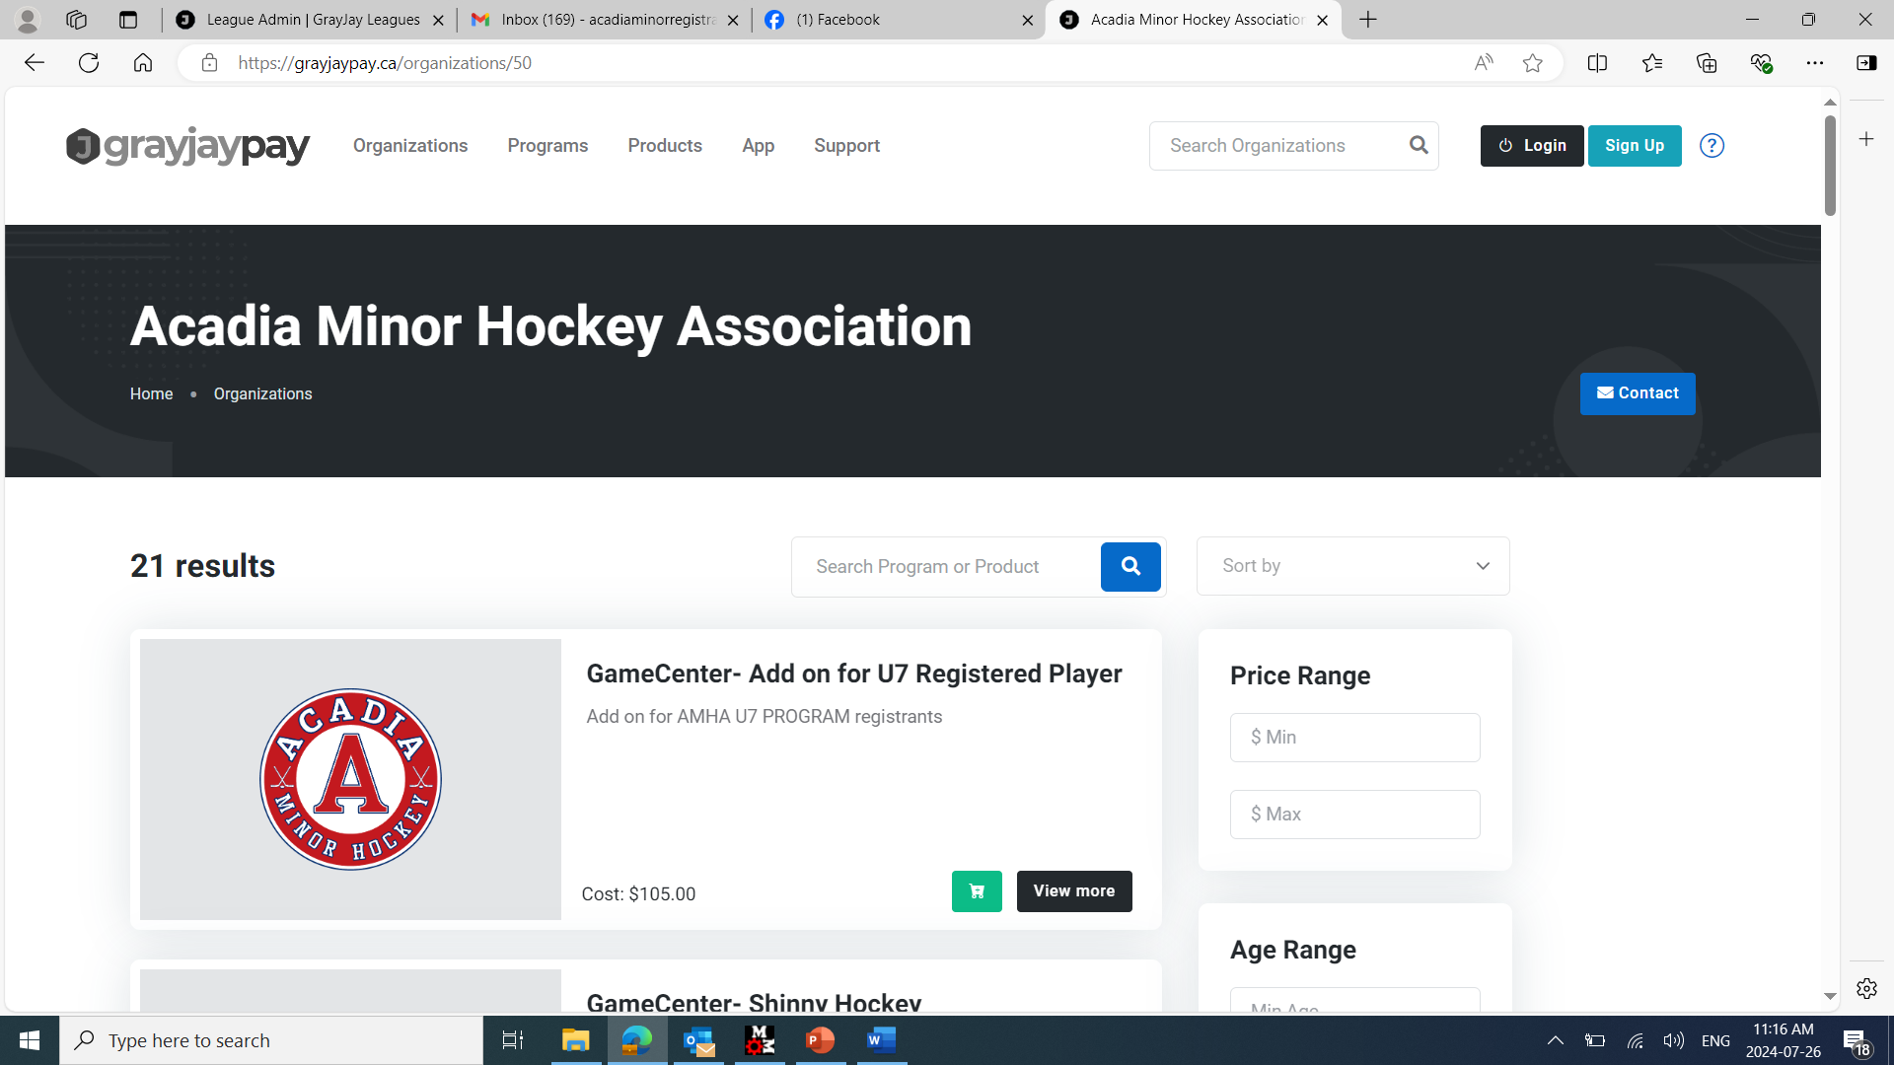

Step 5. Once account is created you will see on the left-hand side where is says “MY FAMILY’- click that and you will see the add family member. Here is where you will use the Hockey Canada Registration # you received in you Respect in Sport course for your child.
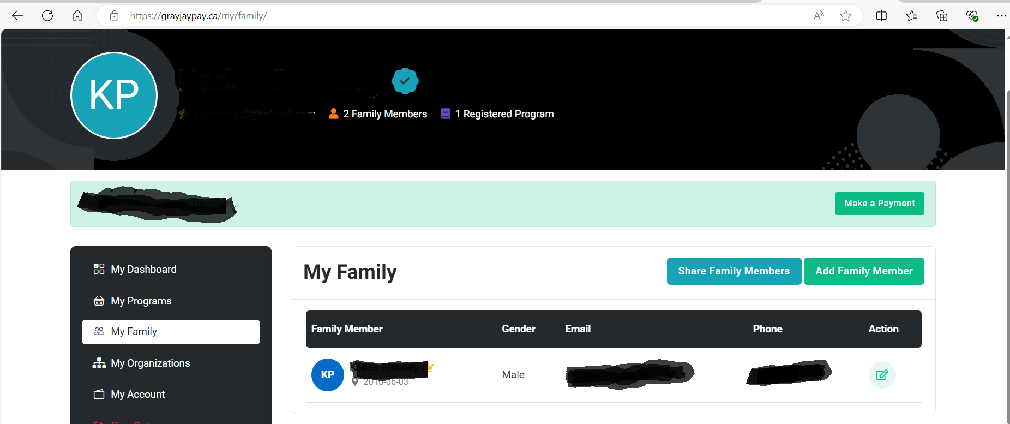

Step 6. You now must add Acadia Minor Hockey as “My Organization” on the left as seen below.

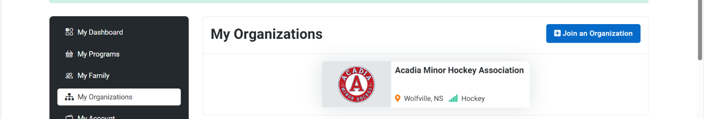

Step 7. From there you can choose what programs you are able to register your child for.

