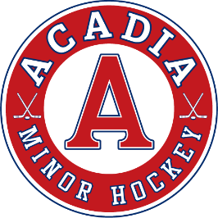
Acadia Minor Hockey Association
PO Box 2440, Wolfville NS B4P 2S3
acadiaminorhockey.ca

June 16, 2024

RE: CRC AND VULNERABLE SECTOR SEARCHES

To Whom It May Concern:
The Acadia Minor Hockey Association (AMHA) is a volunteer organization that provides the opportunity for minor hockey players within the area of Coldbrook, Kentville, Centreville, Canning, Port Williams, Wolfville and the surrounding area to participate in an organized and supervised hockey program. As such, in accordance with our own policies and those of Hockey Nova Scotia, the AMHA requires all volunteer coaches, managers and other support persons to obtain both a criminal record check and a vulnerable sector search every three (3) years.
Approximately fifty (50) of our prospective volunteers will be obtaining their security clearances through the above-mentioned searches. We appreciate the assistance the RCMP has provided in the past in this regard and hope that the same assistance will be available again this year at no charge to our volunteers.
Should you have any questions or comments, please contact me at (902) 791-1184 or jill.sanford@outlook.com

Yours truly,

Jill Sanford
AMHA Risk Management

